For Whom the Bill Tolls:

A Simulated Annealing Model of Draft Legislation in the US Congress

WORKING PAPER

NAMES

Abstract:

# I. Introduction

**WHATEVER THE INTRO IS AFTER WE WRAP UP FINDINGS AND RESULTS**

Research question: how does the draft-bill process impact legislative success? What function does it serve in Congress?

Approach: a simulated-annealing model of policy-development and progress – co-sponsors are solicited in an original round of annealing and the bill is altered accordingly.

# II. Policy Choice in Congress

Building support for legislation is not an easy task. Legislators face a large body of colleagues with heterogeneous preferences. They also face serious consequences if they fail too publically – as ThomasMann once observed, Congressmen feel ‘unsafe at any [electoral] margin’ (Mann 1978). Gary Jacobson details the mechanisms behind their fear: strategic challengers. If an incumbent appears weak (or if national circumstances turn against his party), he will attract strong challengers (Jacobson 1989, 2012). Similarly, the utility of funding to fend off challenges diminishes in these conditions – incumbents actually seem to perform *worse* as they spend more (Jacobson 1990). Policy-making is risky – Gilligan and Krehbiel suggest that policy-makers are, in part, driven by the desire to obtain accurate information regarding the *outcome* of policy, rather than simply attempting to identify the outputs of their actions. They further suggest that legislators are risk-averse in this regard (Gilligan and Krehbiel 1989). Similarly, Arnold (1990) observes that a legislator’s policy activities are highly ‘traceable’ by the legislator’s constituents. It is relatively easy to tie a person to an action. This reinforces legislators’ fears and ensures that public position-taking is a high stakes game.

However, legislators have access to a number of resources to minimize policy-risk. David Mayhew observes that Congress is, for all intents and purposes, designed to fulfill the needs of legislators seeking re-election (Mayhew 1974). Congress grants legislators opportunities to specialize on issues they (and their constituents) care about through the committee system (Polsby 1968, Shepsle and Weingast 1981),resources to gain knowledge about policy in the form of staff (Cain et al. 1987, for example)andaccess to the Congressional Research Service, among other mechanisms. These resources grant legislators some ability to assess the potential consequences of decisions. Networks in Congress (discussed in the next section) also serve this function – networks allow legislators to share information, build coalitions and pool risk.

How do legislators make decisions about policy? Researchers seem to agree on a general hierarchy of goals structured as follows:

1. Reelection (please constituents; do what voters want)
2. Power in the legislature (build supporting coalitions and alliances)
3. Enact preferred policies (personal policy ideas; do what you want)

Mayhew focuses on the first goal exclusively (Mayhew 1974). Fenno (1978) emphasizes this hierarchy, as does Kingdon (1989), in a more elaborate form. Complementary research (Matthews and Stimson 1975) emphasizes ‘cue-taking’ as a mechanism for legislators to reduce uncertainty – if a politician is unsure of a vote (or, by extension, whether to support a policy), they take cues from other, similar members of the legislature. Networks may also play a role in decision-making, as they represent the groups of legislators who are most likely to take cues from each-other. Kingdon attempts to integrate existing theory into a comprehensive model of policy-support, taking the form of a decision-tree. Legislators start their decision-making process by looking for mass-consensus (among others); second, they look for consensus among their core supporters (e.g. voters, interest groups); finally, they look to similar members of the legislature for cues.

Individual legislator decision-making is only part of Congressional policy-making – it is also necessary to consider the dynamics of the chamber itself. Theories of policy-making within Congress divide into two main camps: partisan-theories and preference theories. Partisan policy-making theories emphasize the institutions of Congress, especially committees *and especially* the Rules Committee. By dominating the terms of policy consideration, a party can exercise ‘negative agenda control’ over the legislative process, preventing legislation they do not support from reaching the floor (Cox and McCubbins 1993, 2005). Parties also wield ‘positive agenda control’, the ability to push favored bills through the legislative process (Rohde 1991, Aldrich 1995). On the other hand, one can argue that these institutions may serve the floor just as easily as they serve parties – Keith Krehbiel makes this point, arguing that committees and legislative outcomes are ultimately driven by individual legislator preferences (Gilligan and Krehbiel 1989, 1990, Krehbiel 1991, 1998). While these theories have their differences, they share a keen awareness of the importance of institutional roles and powers in the legislature. The implication of both theories is that policy ought to change substantially as it moves through the legislative process – if committees act as gate-keepers, whether on behalf of their own particularistic interests, the House floor, or party leadership, they should possess the power to shift policy in the direction they desire.

Both theories also suggest the importance of building support for legislation *prior to formal consideration*. Without some level of initial backing, either from party elites or an adequate subset of legislators on the floor, policy is highly likely to die in committee. Legislative productivity data reveals this trend clearly: Table 2.1 charts the percentage of bills introduced that actually received a floor-vote.

The vast majority of legislation goes to committee to die. A random piece of legislation, without co-sponsors or other forms of support, is unlikely to be an exception.The nature of the policy-process also suggests a strong value to establishing support for legislation early: given the power of entrenched forces (whether acting on behalf of party or preferences) at each step of a bill’s progression through Congress a sponsor must carefully marshal a supporting coalition or risk his interests being completely overwhelmed by others.

How do legislatorsbuild an initial base of support for policy? Existing research suggests several mechanisms. First, legislators might discuss their ideas with others informally, or circulate draft legislation to other members as a means of ‘feeling out’ support for a particular policy. This is a good method of obtaining co-sponsor support as well – rather than introduce legislation and wait for others to read it, members are likely to seek out potential backers. There is limited existing research on draft circulation. Nourse and Schacter assess the draft process from a judicial law perspective, noting that drafts are generated primarily by staffers, lobbyists and professional drafters, based on input from legislators (typically in the form of broad summary documents; Nourse and Schacter 2002). This is broadly consistent with research on lobbying strategies: rather than attempt to persuade their enemies, lobbyists function as informational resources for their allies (Hall and Wayman 1990, Hojnacki and Kimball 1998). One of their informational roles is to generate draft legislation and policy ideas.These theories suggest that specific pieces of draft legislation will appeal to certain subsets of legislators. If legislators are hearing similar things from their resources they are likely to develop similar policy ideas and support similar legislation.

# III. Networks in Congress

Network ties between legislators may also contribute to the development of policy. The importance of networks in policy-making is an old idea – Hugh Heclo noted the importance of issue networks in 1978 and the interactions between the public sector and organized interests have been extensively studied ever since (Heclo 1978). Networks in Congress had been comparatively neglected until recently. Talbert and Potoskia note that bill co-sponsorship patterns at early stages of the legislative process demonstrate multi-dimensional agendas (Talbert and Potoskia 2002). This is a surprising finding in light of prior research that emphasizes the unidimsionality of Congressional decision-making (Poole and Rosenthal 1997, prominently). However, the authors do note that legislators seem to converge to a single dimension upon reaching the ‘decision-stage’ of legislation (e.g. a final vote). There are two possible interpretations for this finding. Legislators might simply be exchanging support on issues they don’t care about for support on issues they do (otherwise known as logrolling; see Tulluck 1967, Ferejohn 1986). However, it is also conceivable that negative agenda control restricts the dimensionality of final votes: a bill is not allowed to reach the ‘decision-stage’ without support from important members and these members are unlikely to allow a complex, multi-dimensional bill to reach a floor vote. Such legislation raises many risks and weakens the ability of germaneness requirements to control debate; a multi-dimensional bill may be more subject to ‘killer amendments’ and other oppositional tactics (see, for example, Denzau, Riker and Shepsle 1985, Jenkins and Munger 2003). In other words, agenda control works much better in the case of simple, low-dimensional legislation.

Network structures offer legislators an attractive mechanism to control the dimensionality of legislation and build coalitions before entering a policy into the formal legislative process. Existing literature on co-sponsorship networks suggests that ties between legislators might serve as a powerful means of predicting vote outcomes. Several studies (e.g. Zhang, Friend, Traud, Porter, Fowler and Mucha 2008)use network data to assess political polarization: findings are consistent with more conventional studies of Congressional ideology (e.g. Poole and Rosenthal 1997), indicating that polarization has increased over time, especially in the US House of Representatives.

Tam Cho and Fowler find that Congress follows the pattern of a ‘small-world network’ (Grannovetter 1978). Their research indicates that weak-ties enhance the likelihood of final passage for important legislation (Tam Cho and Fowler 2010). This study builds on Fowler’s earlier work, which developed co-sponsorship network maps in the US House between 1973 and 2010 (Fowler 2006). This research also finds that network ties are powerful predictors of vote-choice – in other words, co-sponsorship coalitions predict final voting coalitions. Bratton and Rouse conduct a similar analysis of US state legislatures and attempt to evaluate the variables that influence tie-formation. They find that co-sponsorship activity is predicted by ideology, district-proximity, demographic homophily and network transitivity (Bratton and Rouse 2011). This research explains the findings of network measures of polarization: ideology influences tie-formation, which in turn leads to the development of ideologically stratified networks.

Analysis of networks in Congress reveals that co-sponsorship ties act as powerful predictors of coalition formation in the legislature. This in turn suggests that the careful cultivation of network ties is a path to power in Congress. We argue that legislators cultivate co-sponsorship relationships, in part, through interactions revolving around draft legislation.

# IV. Informal Policy-Making

Thus far, we have discussed the politics of decision-making in Congress and highlighted the role of informal deliberation and discussion in that process. However, there is one final consideration: the policy agenda.Crucially, the agenda of Congress drives the problems legislators address. The issue-agenda is not under the full control of legislators (as preference and party agenda control theories suggest). Rather, it is driven by necessity (budgets must be passed, some things must be done), exogenous shocks (crises and disasters, such as the September 11th terrorist attacks or the Deep Water Horizon oil spill) and, finally, the vagaries of public opinion. The latter is practically an exogenous shock as well: although we do not wish to dismiss the possibility that the public’s agenda can be influenced, the quantity of actors who desire to do this is so large and varied that it seems unlikely that any one group is able to dominate the agenda of politics for any substantive amount of time.

In certain respects, this theory of agenda setting is analogous to March and Olson’s‘garbage can model’ of organizational decision-making – problems are ‘injected’ into the system through some external process and addressed as they enter (Cohen, March and Olson 1972). We believe that legislators are more strategic than March and Olson would suggest, however. Preferences are powerful forces and existing research strongly emphasizes that legislators are relentless and devious in pursuing their policy goals (whether to facilitate reelection or for other reasons).The key distinction is that the policy agenda space within which legislators act varies. Certain problems must be addressed and legislators must operate within the constraints established by the policy-space (Adler and Wilkerson 2012).

Several existing theories of policy-making emphasize the ‘episodic, event-driven’ nature of policy agendas (Kingdon 1995, Adler and Wilkerson 2012). This process can generate ‘punctuations’ in previously equilibrated policy sub-systems (Baumgartner and Jones 1993). It forces lawmakers to pursue their preferences within a certain agenda space that is not of their design. Adler and Wilkerson express the difference between agenda-centric theories and choice-centric theories succinctly: the former concentrate attention on the *issue agenda*, which can be thought of as a set of policy priorities to be considered (Adler and Wilkerson 2012). The latter concentrates on decisions among competing solutions to these policy priorities – the choice-driven theories constructed by many researchers (e.g. Krehbiel 1993, 1998, Cox and McCubbins 1994, 2003).

This paper considers the role of informal deliberations in forming policy solutions – we develop a theory of policy-making oriented around draft-legislation and pre-legislative coalition building.Circulating draft legislation has two functions in our theory: to build initial support for legislation in order to raise the odds of success and to gain information about the latent distribution of preferences on the issue being raised in the bill. Legislators may know a great deal about their colleagues, but they are unlikely to be sure where a given individual will fall on a given issue. This knowledge gap grows larger as legislation grows more complex – rather than a simple yes/no assessment of support, legislators must evaluate many competing interests within a single bill. This is quite a challenge on an individual level; it is even more challenging when one attempts to predict how another might respond to a particular bill. Finally, the dynamics of policy agendas suggest that legislators face a constrained set of problems. The objective of forming solutions through informal coalition building is to control the solution environment, developing a piece of legislation that addresses the relevant problem while also allowing other legislators to take advantage of the opportunity by adding their own solutions and issues of interest.

The original bill sponsor, a legislator who has decided to attempt to make policy, is faced with a choice: should he distribute his policy proposal widely and attempt to solicit broad support? Or, should he keep distribution relatively restricted, retaining more certainty over content? We assume that once a policy is released it is largely removed from the sponsor’s hands. Admittedly, this is not literally true: a sponsor can always withdraw legislation. However, we believe it is effectively true – even if a sponsor withdraws from legislation in response to substantial changes made by others, the other legislators may easily re-introduce new, equivalent legislation. In other words, the sponsor’s primary role is to introduce a policy issue into the legislative arena and to propose a solution – the outcome of his action is left in the hands of his colleagues.

There are recent examples of this form of informal, sub-group policy-making. Consider the various informal ‘gangs’ of legislators that coalesced around competing solutions to the 2012-2013 budgetary crises (e.g. the ‘Gang of 6’). These groups represent initial sub-sets of legislators considering draft legislation – in most cases they had no formal authority beyond some degree of respect from their peers. Ultimately, their proposed solution failed to become policy. This outcome was seen as a failure of bipartisanship and moderate politics – our theory views it, in contrast, as a failure to understand the dynamics of informal policy-making. The ‘Gang of 6’ was too small to make an impact – while negotiation is easier among small groups, there is simply no guarantee that agreement among a small subset of a legislative body will translate into support within the entire body. In this case, it did not.

# V. An Simulated Annealing Model of Informal Policy-Making

In this section, we present a model of informal policy formation based on simulated annealing. **SHORT DESCRIPTION OF WHAT S-A IS?** Conceptually, a bill is sponsored and considered by a network of legislators. This initial, informal group of policy-makers develops the framework of legislation through a round of annealing and builds some support for passage. Their work is then referred to a committee of interested members, who are allowed to alter the legislation through an additional round of annealing. This second alteration is analogous to committee agenda-setting powers (Cox and McCubbins 1993, 2004). A description and discussion of the details of the model follows.

## Model Overview

Each realization of the simulation is initialized with a new group of legislators. These legislators have a list of priorities and positions associated with a list of issues – one may think of these as the solutions and problems in the Garbage Can Model, with the added dimensionality of priorities. Legislator priorities and positions may or may not conform to ideological party agenda depending on model parameters. A social network connecting the legislators is generated, using both homophily [TBD: reference neded] and preferential attachment [Barabasi and Albert, 1999].

As the simulation runs, bills are sequentially processed as follows:

1. Proposal:
   1. A random legislator is chosen to sponsor a bill.
   2. The sponsor proposes a draft bill on any issue that has not already been addressed by law.
2. Draft circulation among cosponsors:
   1. All legislators connected to the sponsor in the social network are selected as cosponsors.
   2. The cosponsors revise the draft using simulated annealing; new issues may be added to the bill during the revision process and solutions on existing issues may change.
3. Committee review:
   1. The draft is referred to a committee; committees are chosen according to legislators for whom the main issue of the bill is a high priority.
   2. The committee revises the bill by simulated annealing; again, new issues may be added and existing solutions changed as a result.
4. Floor vote:
   1. The bill is referred to the floor for a vote.
   2. If the bill passes by simple majority (> 50% votes), the bill is made into law; i.e., the solutions addressed by the bill are recorded and the issues may not be revisited for the remainder of the realization.

This process is repeated for 200 proposals (or halts if all issues are passed into law).

The model is implented in Python with object-oriented programming, and there are three high-level classes that interact in the model: *State, Legislator,* and *Bill*. These are further described in separate sections below.

The fixed and free parameters of the model are listed and described in Tables TBD and TBD; further implementation detail is addressed in the sections that use them. The simulated annealing parameters are discussed separately in the simulated annealing section of this paper.

|  |  |  |
| --- | --- | --- |
| Parameter | Description | Value |
| Num_of_Representatives | Size of the legislative body. | 100 |
| Num_of_Issues | Size of the problem set. | 75 |
| Solution_Bit_Length | Bit string length of positions and solutions. | 4 |
| Committees_Per_Legislator | How many committees a legislator belongs to; sets the lowest priority issue a legislator will serve on committee for. | 4 |
| Satisfaction_Threshold | The minimum satisfaction a legislator must have with a bill to vote “aye” on it. A calibrated value (see Model Calibration section), but after calibration was fixed for experiment variations. | 0.675 |
| Friend_Threshold | The minimum homophily (range [-1,1]) for legislators to be considered for preferential attachment. | 0 |
| Minimum_Friends | The number of links added as each legislator is added to the network. | 5 |

Table 1 - Fixed parameters

|  |  |  |
| --- | --- | --- |
| Parameter | Description | Experiment Variation |
| Unaffilitated_Fraction | Fraction of the legislative population with no ideological party affiliation. | [0.05, 0.5, 1.0] |
| Green_Fraction | Fraction of the party-affiliated population belonging to the “Green” party. Remainder belong to the “Yellow” party. | [0.5, 0.75, 1.0] |
| Ideology_Issues | Ideological platform issues for the parties. | [0, 5] |
| State_Priorities | High-priority issues for all legislators. | [0, 5] |

Table 2 - Free parameters of the model

## Global Method *binaryTreeDistance()*

The global method *binaryTreeDistance()* is used in various places to calculate homophily between two bit strings – for example, between two legislator positions on an issue, or between a proposed solution and a legislator’s ideal solution (his position on the issue). This function calculates the distance as increasing depth on a binary tree, where the most significant bit (MSB) of the two bit strings is worth 50% similarity, the next MSB is an additional 25 similarity, etc. Two identical strings result in 100% similarity, whereas strings that have only the MSB in common are only 50% similar. At position *i* in the bit strings, a bit’s difference in the binary value results in an additional (½)i+1 reduction in similarity. For an infinitely long bit string length, similarity in all positions but the MSB would result in a 50% similarity as well; practically speaking, however, since our model only uses a bit string length of 4, the maximum achievable *dis*similarity is 93.75%.

This method was used to enable strong issue position correlation between party-affiliated legislators while still allowing for some heterogeneity among their positions, if for example, party positions were only specified to *n* most significant bits of *Solution_Bit_Length*. However, this feature was not used in this model (party platform positions are homogeneous among affiliated members) and could be an extension in future work.

Another benefit to this method, however, is that on any given issue, it generates a bimodal, vs. uniform, distribution of all legislator positions. In a completely uncorrelated population (i.e., all independents), a uniform significance of bits towards homophily created an extremely low likelihood of any two legislators having sufficient agreement over the entire solution space to meet any reasonable assumption of friendship threshold. The decreasing significance of the binary tree method is more reasonable in that it could be said to model any two legislators agreeing on the generalities of a solution to an issue (say “for” or “against”) while perhaps differing on implementation details. From a model implementation perspective, it makes the network generation much more tractable using reasonable assumptions of friendship threshold.

## The State Class

The state is a singleton class and the main simulation object. Its main functions are to initialize party agenda (priorities and positions on the issues list), initialize the legislators with party affiliation and issue priorities and positions, call the network generation method (which is actually a static method of the *Legislator* class), and process bills.

### The State: Attributes/Members

Table TBD identifies the *State* class attributes and object members.

|  |  |  |
| --- | --- | --- |
| Attribute | Description | Initialization |
| issues | A list of potential problems to be addressed by the legislative body. | [0, 1 .. Num_of_Issues-1] |
| legislators | List of individual legislators making up the legislative body. | (see text) |
| laws | A dictionary, keyed by issue, of solutions to issues that have been passed into law. | {empty} |

Table 3 - The State class attributes and object members

### The State: Initialization

The State initializes a set of state priorities for all legislators, party platform issues and associated seed priorities and positions. State priorities are simply the first n=*State_Prioritie*s of *State.issues*. Party platform issues are a random sample (n=*Ideology_Issues*) for each party from among the remaining issues (i.e., not state priorities).

The seed priority list is a concatenation of the platform priorities and the state priorities; this list is rank-ordered so that state priorities are likely to be higher priority than platform priorities. “Seed” refers to the fact that there is a stochastic process (preferential attachment) that generates the actual individual priorities for each legislator, as described in more detail in legislator initialization. To maintain parity of state issue priorities between independents (non-affiliated) and party-affiliated legislators, independents are effectively initialized with their own individual platform of n=Ideology_Issues priorities; like party priority issues, this is a random sampling for each independent.

For each issue in the seed priority list (platform issues plus state priorities), the associated Green position is a bit string of 1’s of length *Solution_Bit_Depth* (4 for our model), and the associated Yellow position is a bit string of 0’s. Green legislators will also have a “1’s” position on Yellow priority issues, and the converse. Thus, our model assumes that although ideological parties may prioritize different problems, they differentiate from each other along non-prioritized problems as well [TBD: reference needed?]. Independents have no *a priori* positions.

Legislators are then generated with a party affiliation, seed priorities list, and a set of positions on issues. Finally, the network is generated.

### The State: Behaviors

Table TBD identifies the methods associated with *State* class behavior. These will be further described in the sections immediately following.

|  |  |
| --- | --- |
| Method | Description |
| step() | Executes one tick of the simulation, wherein a bill is proposed, draft revised with cosponsors and committee, and voted on. |
| getCommitteeMembers() | Returns a list of legislators for whom the bill’s main issue is high priority. |
| circulateBill() | Given a list of reviewers, revises the bill with simulated annealing. |
| putToVote() | Returns the “aye” vote tally on the bill. |
| makeLaw() | Adds any solution addressed in the bill to the list of laws. |

Table 4 - State class methods

#### State Method: step()

The step() method implements steps 1 - 4 as described in the “Model Overview” section above.

#### State Method: getCommitteeMembers()

In this method, any legislator for whom the bill’s main issue is in that legislator’s highest n=*Committees_Per_Legislator* priorities will be added to the committee.

#### State Method: circulateBill()

This method takes as argument the list of reviewers (cosponsors or committee) slated to revise a bill and calls the simulated annealer static method *anneal()* with a “rev dash” revision (current solutions in the bill), a modification method *bill.revise()*, and an objective/energy function *bill.measureDisSatisfaction()*. The best solution from the simulated annealing is returned as the revision.

#### State Method: putToVote()

This method calculates the number of legislators for whom the bill’s final solution vector meets the minimum satisfaction threshold.

#### State Method: makeLaw()

If the bill passes, this method creates a new dictionary entry in *State.laws* for each solution in the bill’s solution space.

## The Legislator Class

Legislators propose (sponsor) bills, cosponsor bills, serve on committees, and vote on finalized revisions.

### Legislator: Attributes

Table TBD identifies the attributes of *Legislator* class objects.

|  |  |  |
| --- | --- | --- |
| Attribute | Description | Initialization |
| priorities | A dictionary of priorities accessed by issue. | algorithm (see text) |
| positions | A dictionary of positions accessed by issue. | algorithm (see text) |
| affiliation | Which party (none, green, or yellow) the legislator belongs to. | as determined by the State class |
| links | A list of other legislators this legislator is connected to in the social network. | algorithm (see description of *preferentialHomophilyNetwork())* |

Table 5 - Legislator attributes

### Legislator Initialization

The legislator’s constructor is passed three values from the *State* class: a party affiliation, seed priorities, and default positions.

#### Legislator Priorities Generation

Recall that seed priority issues are generated by the State object and are a rank ordered concatenation of party-prioritized issues (nparty = *Ideology_Issues*) and state-prioritized issues (nstate = *State_Priorities*). Starting with element 0 in this priority issues list and proceeding to the end of the list (element N-1, where N = nparty + nstate), a priority 2*(i + 1) is initially assigned to that issue. Thus, the lowest priority issue will be assigned an initial priority of 2, and the highest priority issue will be assigned an initial value of 2*N. All remaining issues (*Num_of_Issues* – N) are assigned an initial priority of 1.

Over *Num_of_Issues*2 iterations, issues are incremented, with the issue to be incremented at each iteration chosen at random according to the probability density of priorities in that iteration. Finally, priorities are normalized to the range [0,1]. This preferential attachment method generates a power law distribution of priorities, so that a legislator places very high priority on a small number of issues but low priority on most issues. The use of the seeded priority issues list means that legislators have some correlation in priorities to the extent that their seed priorities are the same, but heterogeneity is introduced with stochasticism.

#### Legislator Positions Generation

For any party agenda issues passed to the constructor by the state, the legislator adopts the party platform position [TBD discuss assumption, future work]. For all other issues, positions are assigned randomly from the range [0, 2*Solution_Bit_Length*-1], inclusive (i.e., a random bit string of length *Solution_Bit_Length*).

### Legislator: Behaviors

Table TBD identifies the methods of the *Legislator* class.

|  |  |
| --- | --- |
| Method | Description |
| preferentialHomophilyNetwork() | Generates the social network of the legislative body. See below for detailed description. |
| proposeBill() | Randomly selects an issue to sponsor from among any issues not already passed into law. |
| pickCoSponsors() | Returns all legislators ego is connected to in the social network. |
| getSatisfactionWithBill() | Returns the legislator’s satisfaction with the solutions proposed by the bill. See text below for more detailed description. |

Table 6 - Legislator methods

#### Legislator class static method: preferentialHomophilyNetwork()

This method takes as argument the set of legislators initialized with priorities and positions, and generates a social network among them. Both homophily and preferential attachment are used. Figure TBD is a diagram of the main steps in the network generation.

Find potential friends using homophily

Link to a potential friend using preferential attachment

Remove friend from potential friends

Shuffle legislator list

*ith* legislator

Iterate *Minimum_Friends* times

Iterate over all legislators

Figure 1 – Diagram of network generation using preferential attachment with homophily.

*Potential friends* are the set of legislator alters who have a minimum similarity of *Friend_Threshold* total homophily on all issues with ego. Similarity is a sum of homophilies on positions of all issues, weighted by and normalized to ego’s priorities on those issues. Homophily on an issue is the unary inverse (*1 – x)* of the *binaryTreeDistance()* calculated on a pair of legislators’ respective positions on that issue.

Edge assignment is as described in [Barabasi and Albert, 1999]: each time an edge is added, a pdf is generated from the degree distribution in the subnetwork of *potential friends*, and a target node for the edge is selected randomly from that pdf.

#### Legislator object method: proposeBill()

Legislators introduce a bill on an issue randomly selected from any issues not already passed into law. The legislator’s proposed solution for that issue is his position on that issue.

#### Legislator object method: getSatisfactionWithBill()

A legislator’s satisfaction with a bill is calculated the same way as similarity between two legislators: a priority-weighted and -normalized sum of homophilies between the legislator’s issue positions and the bill’s proposed issue solutions.

## The Bill Class

The *Bill* class is a container object for solutions to issues, and has two relevant methods: *revise()* and *measureDisSatisfaction()*.

### Bill: Attributes

Table TBD identifies the attributes of *Bill* class objects.

|  |  |  |
| --- | --- | --- |
| Attribute | Description | Initialization |
| solutions | A dictionary of solutions to issues, indexed by issue | A single entry, as determined by the sponsor |
| main_issue | The issue on which the bill is introduced | as determined by the sponsor |

Table 7 - Bill attributes

### Bill Initialization

A bill is initialized with a single entry in the solutions dictionary: the solution proposed by the sponsor.

### Bill: Methods

The *Bill* class has only two methods, as required for the simulated annealer: *revise()* and *measureDisSatisfaction()*.

#### Bill class object method: revise()

This method is passed to the simulated annealer as the modifier function. Each time it is called, it makes one change to the bill. An issue is randomly selected from any open issues (not addressed by existing law). If that issue is in the bill’s current solution set, one of the bits in that solution is randomly selected for inversion. If the issue is not already addressed by the bill, a random solution on that issue is added and added to the bills *solutions* dictionary.

#### Bill class object method: measureDisSatisfaction()

This method is passed to the simulated annealer as the objective (or energy) function. Given a set of reviewers (this may be either cosponsors, committee, or, for model metric purposes, the entire legislative body) and calculates the average satisfaction with the bill as determined by a *Legislator* object’s *getSatisfactionWithBill()* method. It returns the negative of this average: higher dissatisfaction with a bill corresponds to higher energy in simulated annealing, lowering the probability of acceptance.

## Simulated Annealing

The simulated annealer implements the Metropolis algorithm for simulated annealing [TBD reference needed]: a state with lower energy than the current state is accepted, while a state with higher energy is accepted with probability . The annealer iterates over the temperatures provided to it in the annealing schedule, and for each temperature, iterates the corresponding number of times provided to it. Each iteration, the modifier function is called on the current state, and the modified state’s energy is calculated per the objective function; the modified state’s energy is then accepted or rejected. The final state returned by the algorithm is the lowest energy (highest satisfaction) one encountered.

For our model, k was chosen to be . This means that, at a temperature of 1.0, a decrease of 0.1 in satisfaction is accepted with probability ½.

The time at temperature annealing schedule was configured linearly, as listed in Table TBD.

|  |  |
| --- | --- |
| Temperature | Time at |
| 1.0 | 2 |
| 0.8 | 4 |
| 0.6 | 6 |
| 0.4 | 8 |
| 0.2 | 10 |

Table 8 - Simulated annealer schedule

# Model Verification, Validation, and Calibration

The model was verified through code review and incremental testing: subunits of functionality were tested by verifying expected intermediate outputs, before implementing more complex functionality.

As an exploratory model, little effort was made to validate outputs. Where applicable, assumptions have been stated and are validated against either literature or reasonable expectation. For example, the *Committees_per_Legislator* model parameter is based on the maximum number of committees a congressperson can serve on.

The model parameter *Satisfaction_Threshold* was calibrated to the value 0.675 to achieve an about 4% passing rate of all initial proposals, with *Unaffiliated_Fraction* = 0.05, *Green_Fraction* = 0.5, and *Ideology_Issues* and *State_Priorities* each set to 5. A 4% passing rate agrees with typical U.S. Congress pass rates, which are between 2% and 7% [TBD reference?]

# Experimentation Method

A suite of experiments were run against all combinations of parameter values identified in Table 2. An exception was any variation in *Green_Fraction* when *Unaffiliated_Fraction* was 1.0, which would have been duplicative results since party affiliation is moot in that case; a separate experiment was run to obtain results with *Unaffiliated_Fraction* = 1.0 and variations over *Ideology_Issues* and *State_Priorities*. To obtain statistically significant results, 30 realizations were simulated for each parameter combination.

Tables TBD and TBD identify the metrics that were calculated or recorded for each proposal during individual run histories and for final aggregate outputs after a completed simulation, respectively. To keep the data set manageable, run histories were not recorded for the main suite of experiments. Instead, histories were only recorded for the baseline model: *Unaffiliated_Fraction=0.05, Green_Fraction=0.5, Ideology_Issues = 10.*

|  |  |
| --- | --- |
| Output | Description/Notes |
| main issue |  |
| congress initial dissatisfaction |  |
| provisional tally | How many votes the initial proposed solution would have received if put immediately to vote. |
| cosponsors |  |
| cosponsor initial dissatisfaction |  |
| cosponsor final dissatisfaction |  |
| committee size |  |
| committee initial dissatisfaction |  |
| committee final dissatisfaction |  |
| number of issues addressed | Number of issues addressed in the final bill version |
| main issue change | binary tree distance between the main issue final solution and the original proposed solution |
| congress final dissatisfaction |  |
| votes |  |

Table 9 - Metrics captured for each proposal during a recorded history

|  |  |
| --- | --- |
| Output | Description/Notes |
| proposals | In rare instances, the legislative body passed laws on all issues in the problem space before the simulation run time. This metric allowed capture of those instances. |
| laws count | How many bills were passed into law. |
| provisions | How many issues were passed into law. |
| total satisfaction | Final legislative body satisfaction with all legislation. |
| total change | average change in the main issues’ positions from proposal to law |
| total votes | How many votes were cast ‘aye’ over the simulation run. |

Table 10 - Aggregate metrics recorded for each simulation realization

# VI. Results

We describe three sets of results: the networks, session histories and aggregated experiment results. The experiment results command the bulk of our attention below, whereas the network analysis and session histories support explanation and validation of the model description, above.

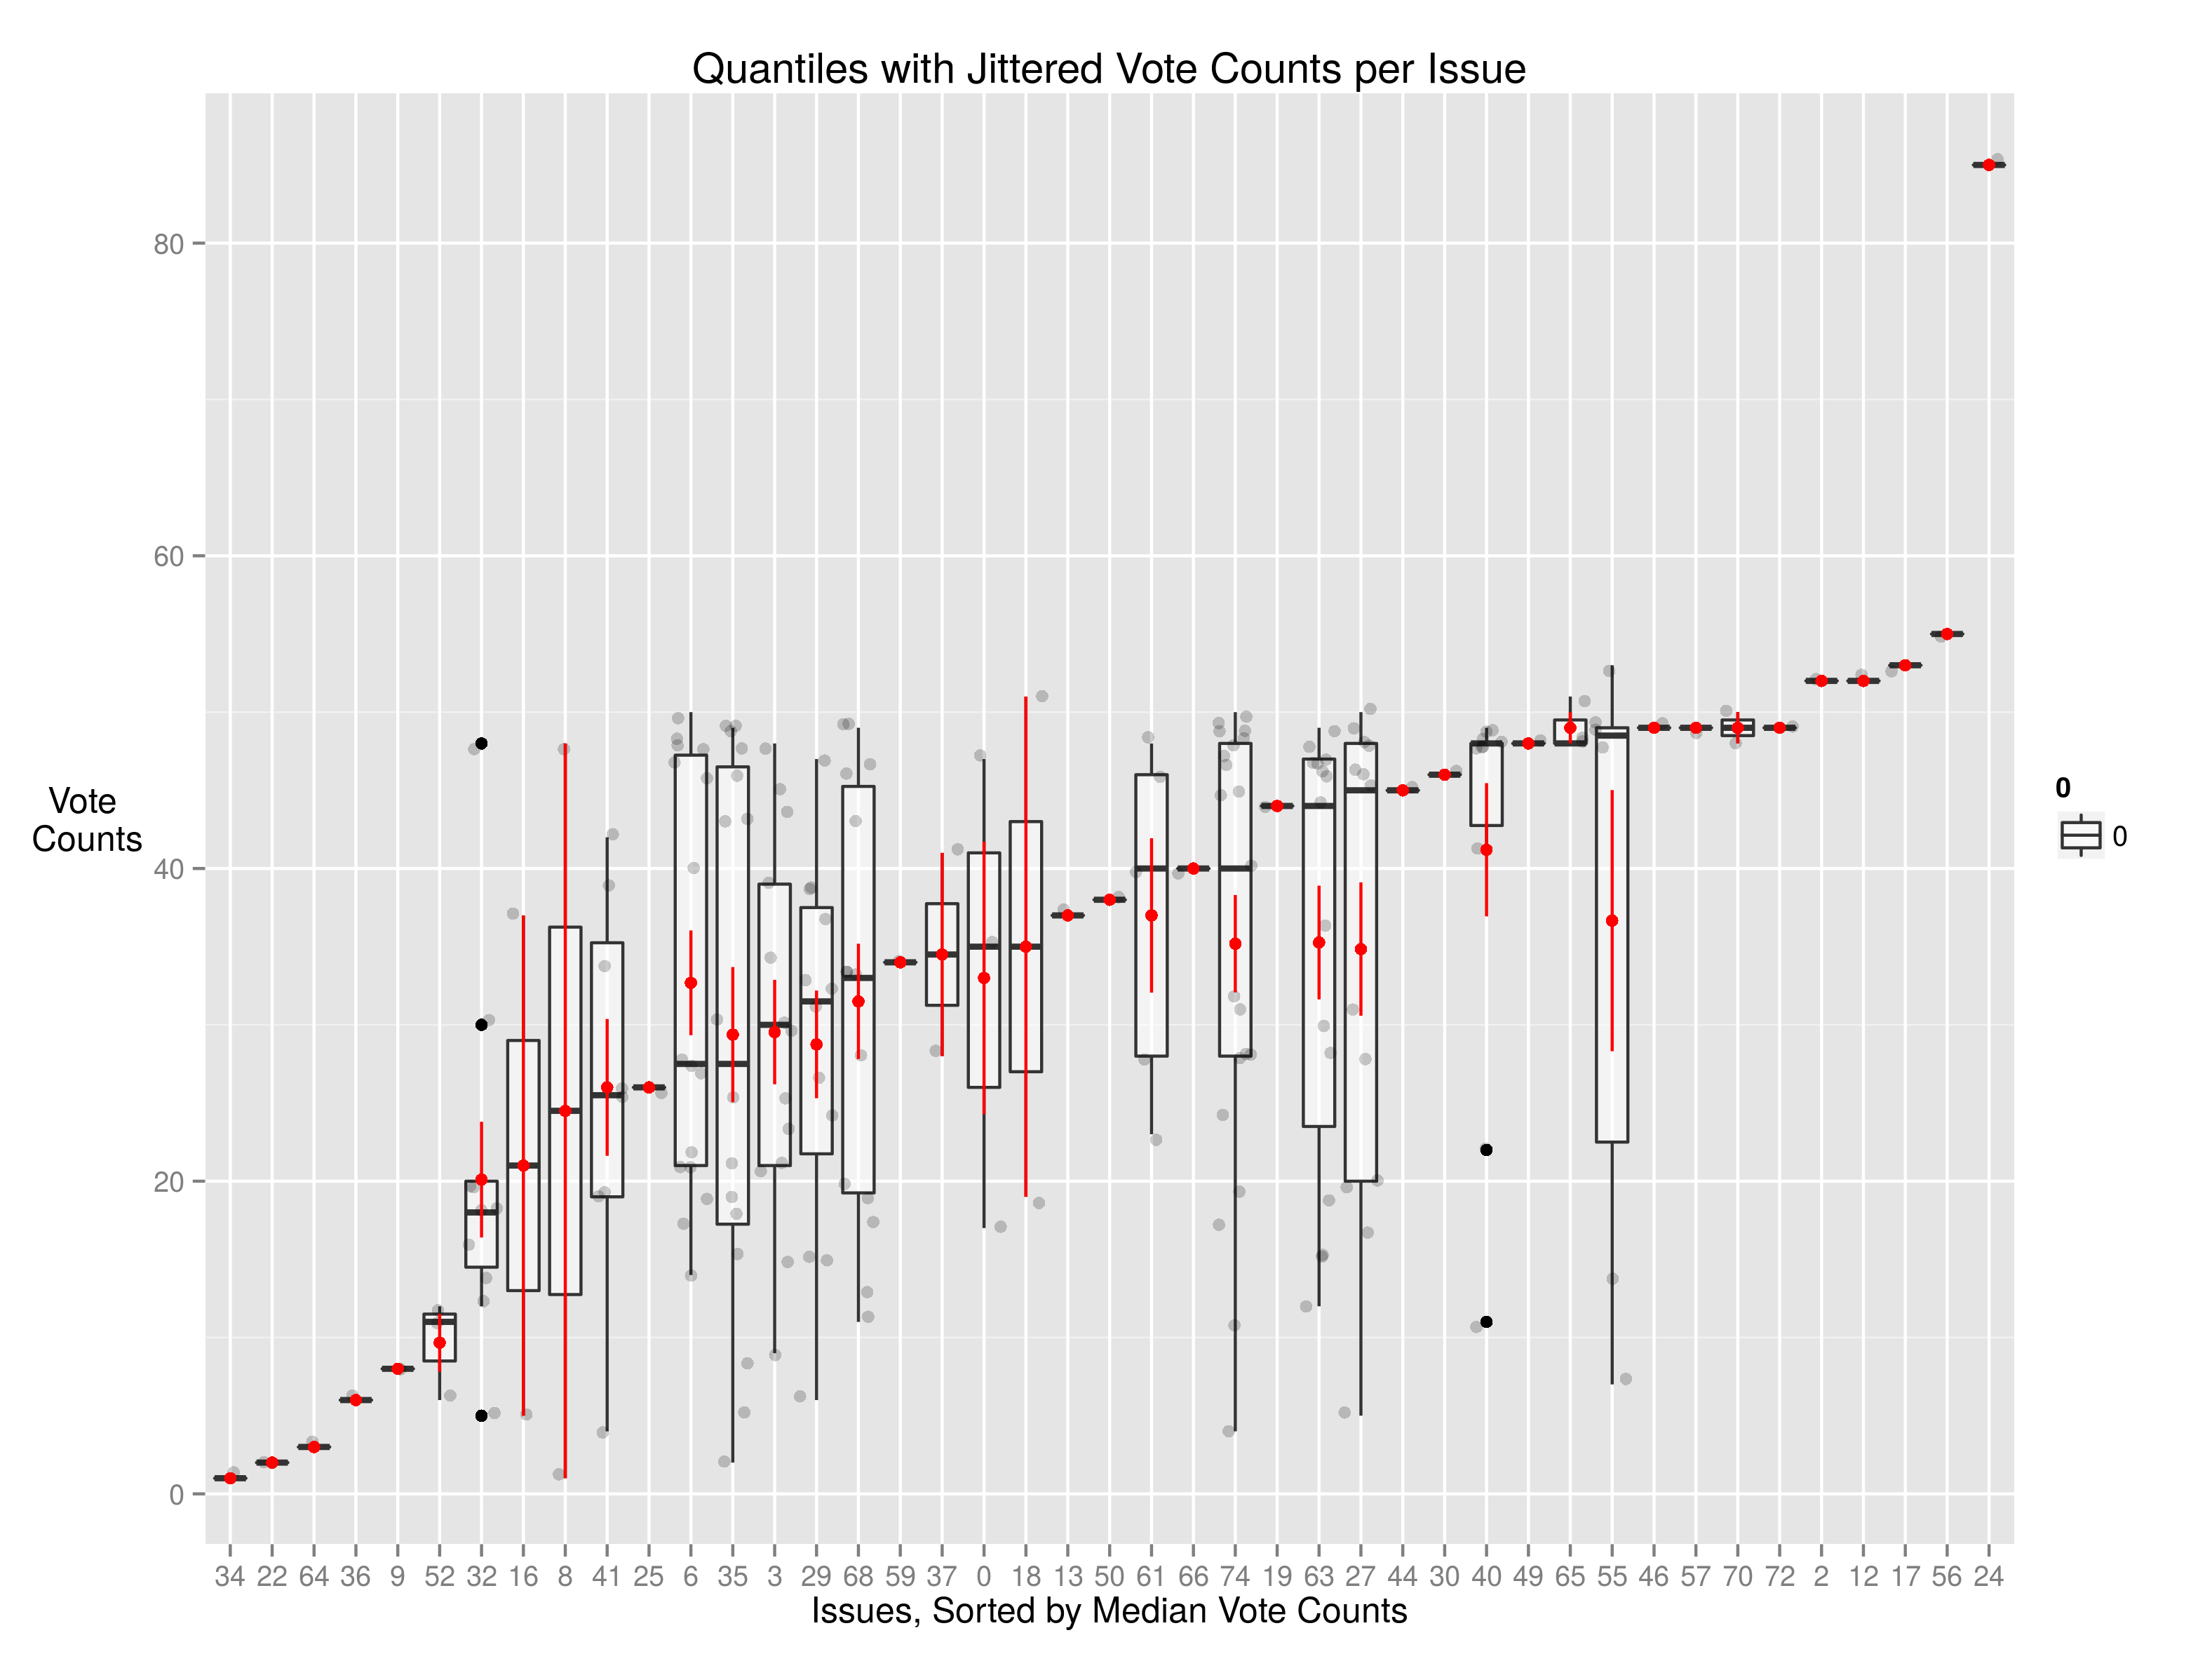

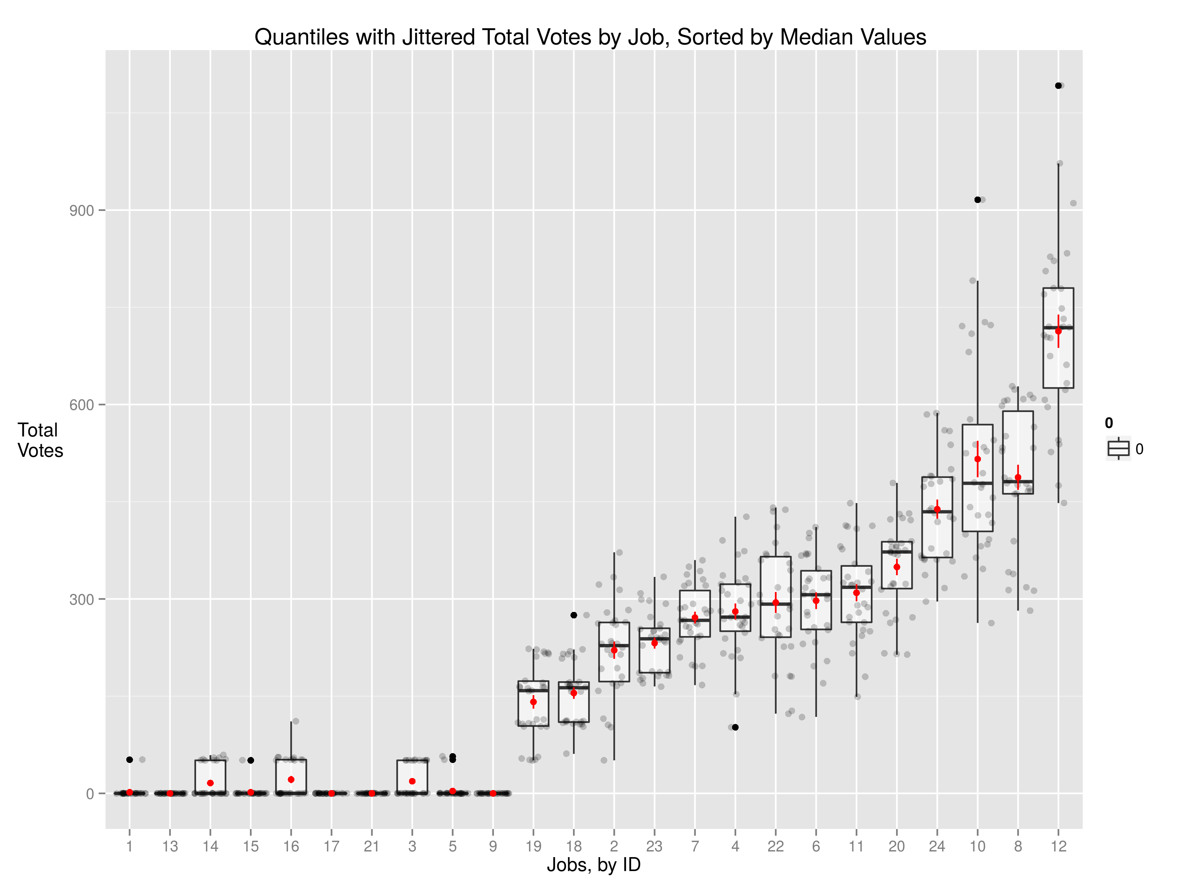

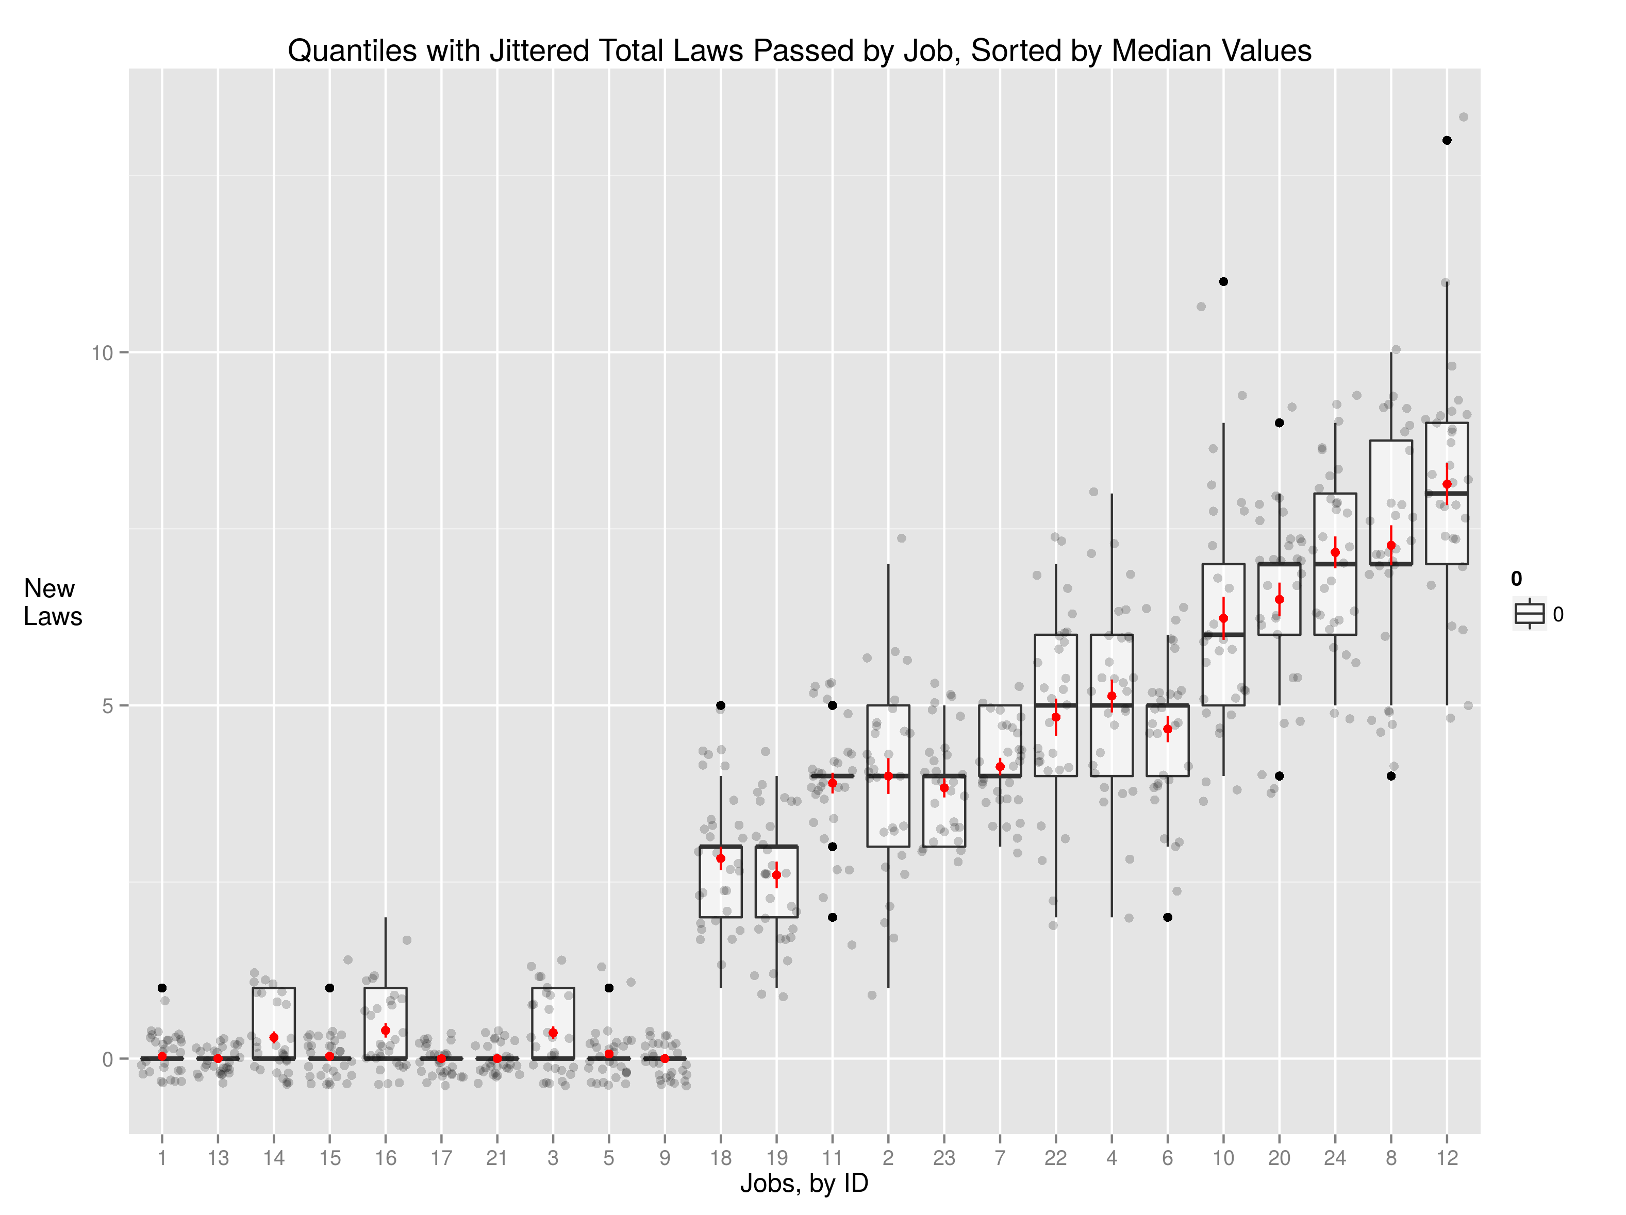

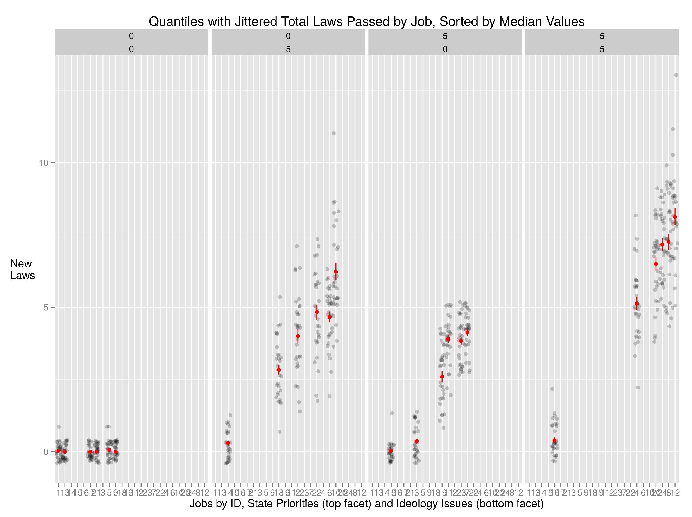

Some experiment configurations---xyz---regularly did not produce any laws. Figures below exclude those configs, except as noted.

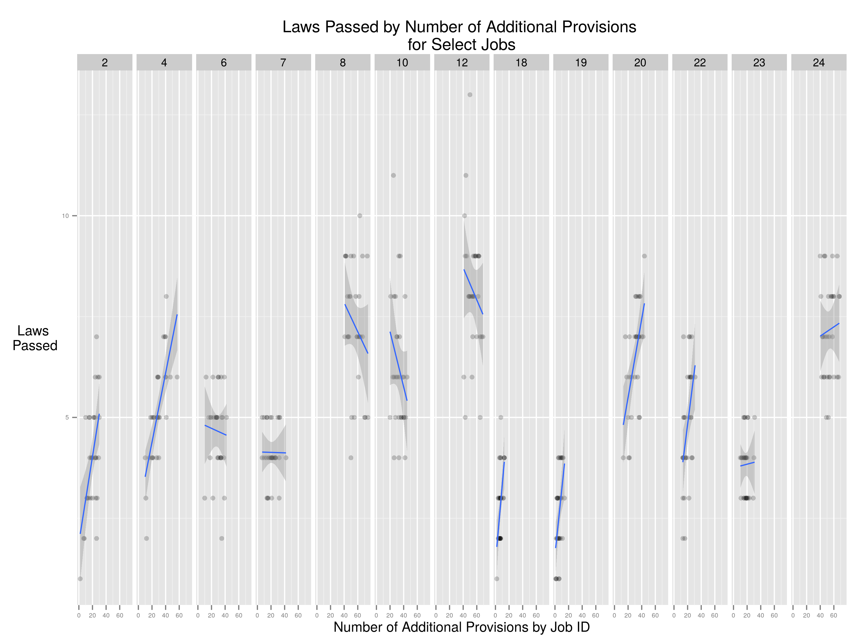

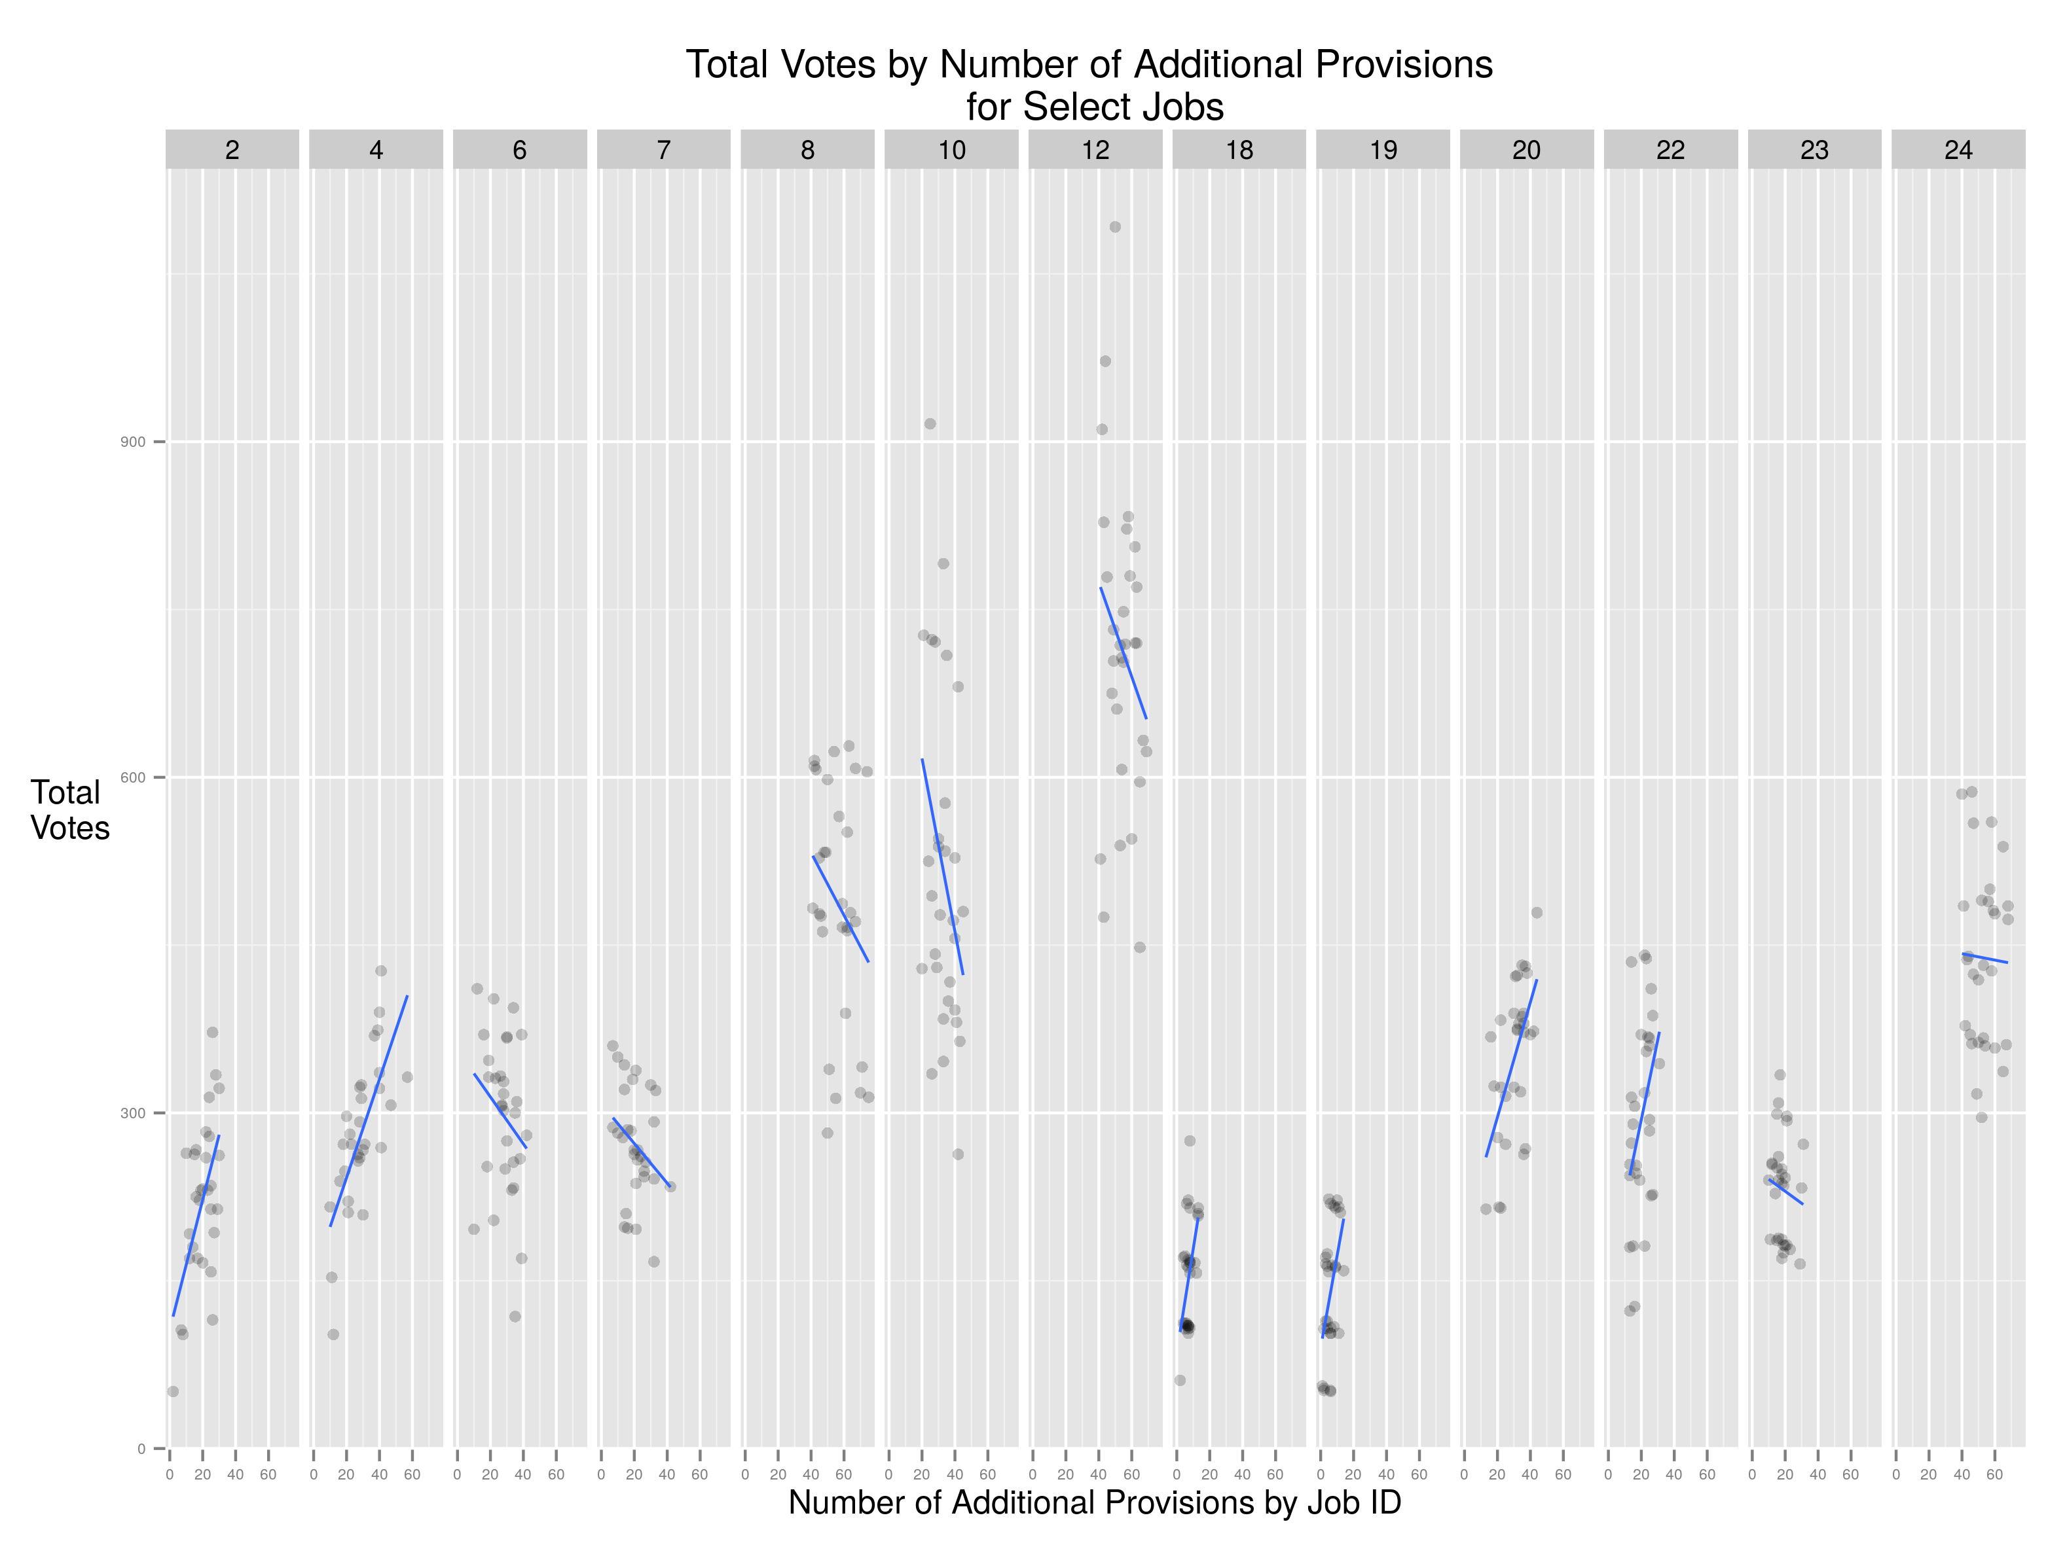

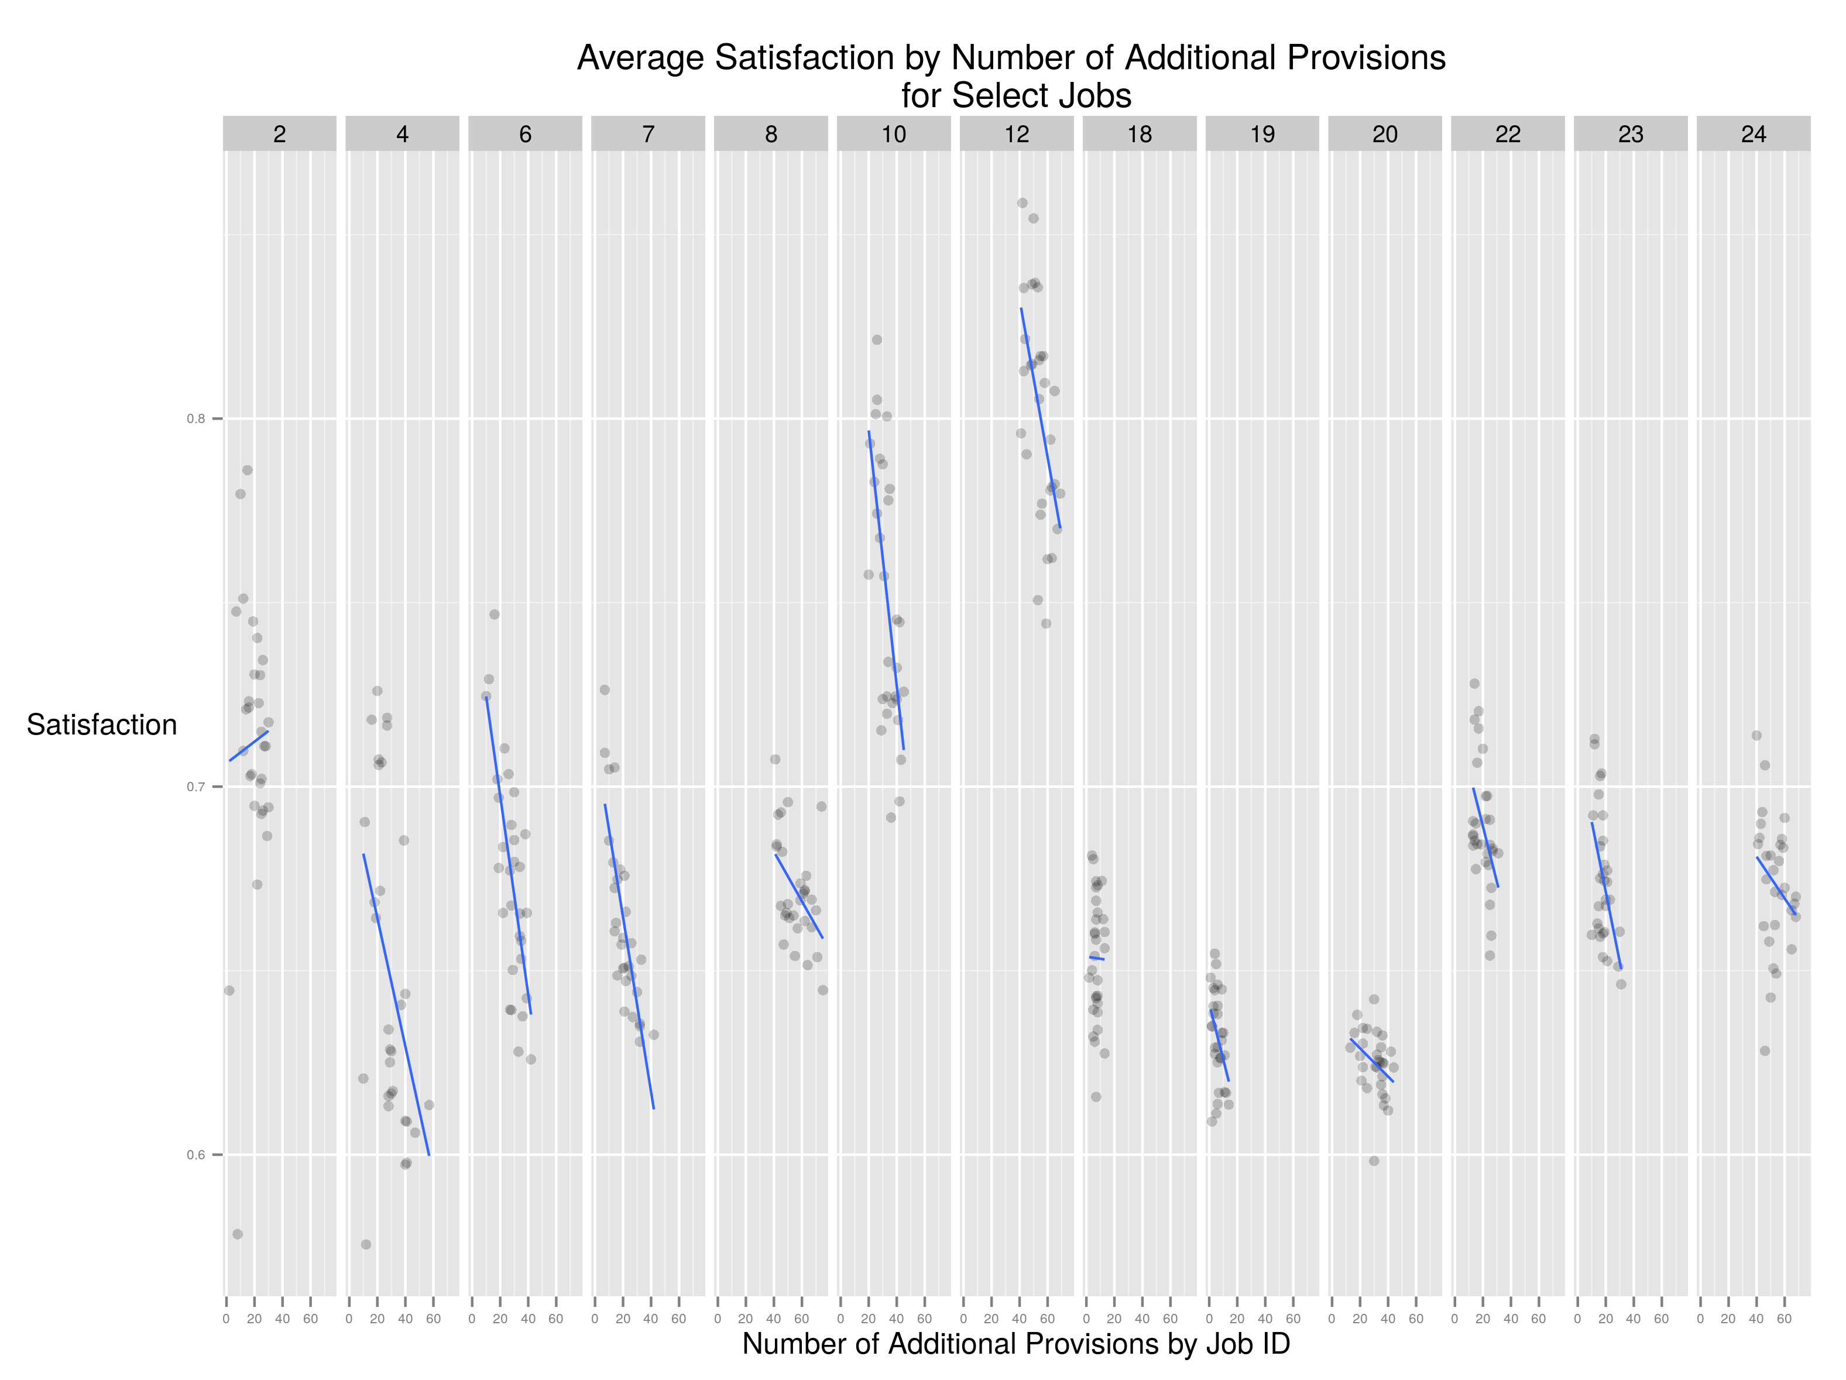

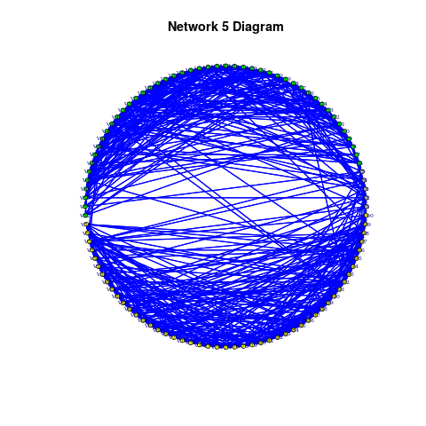

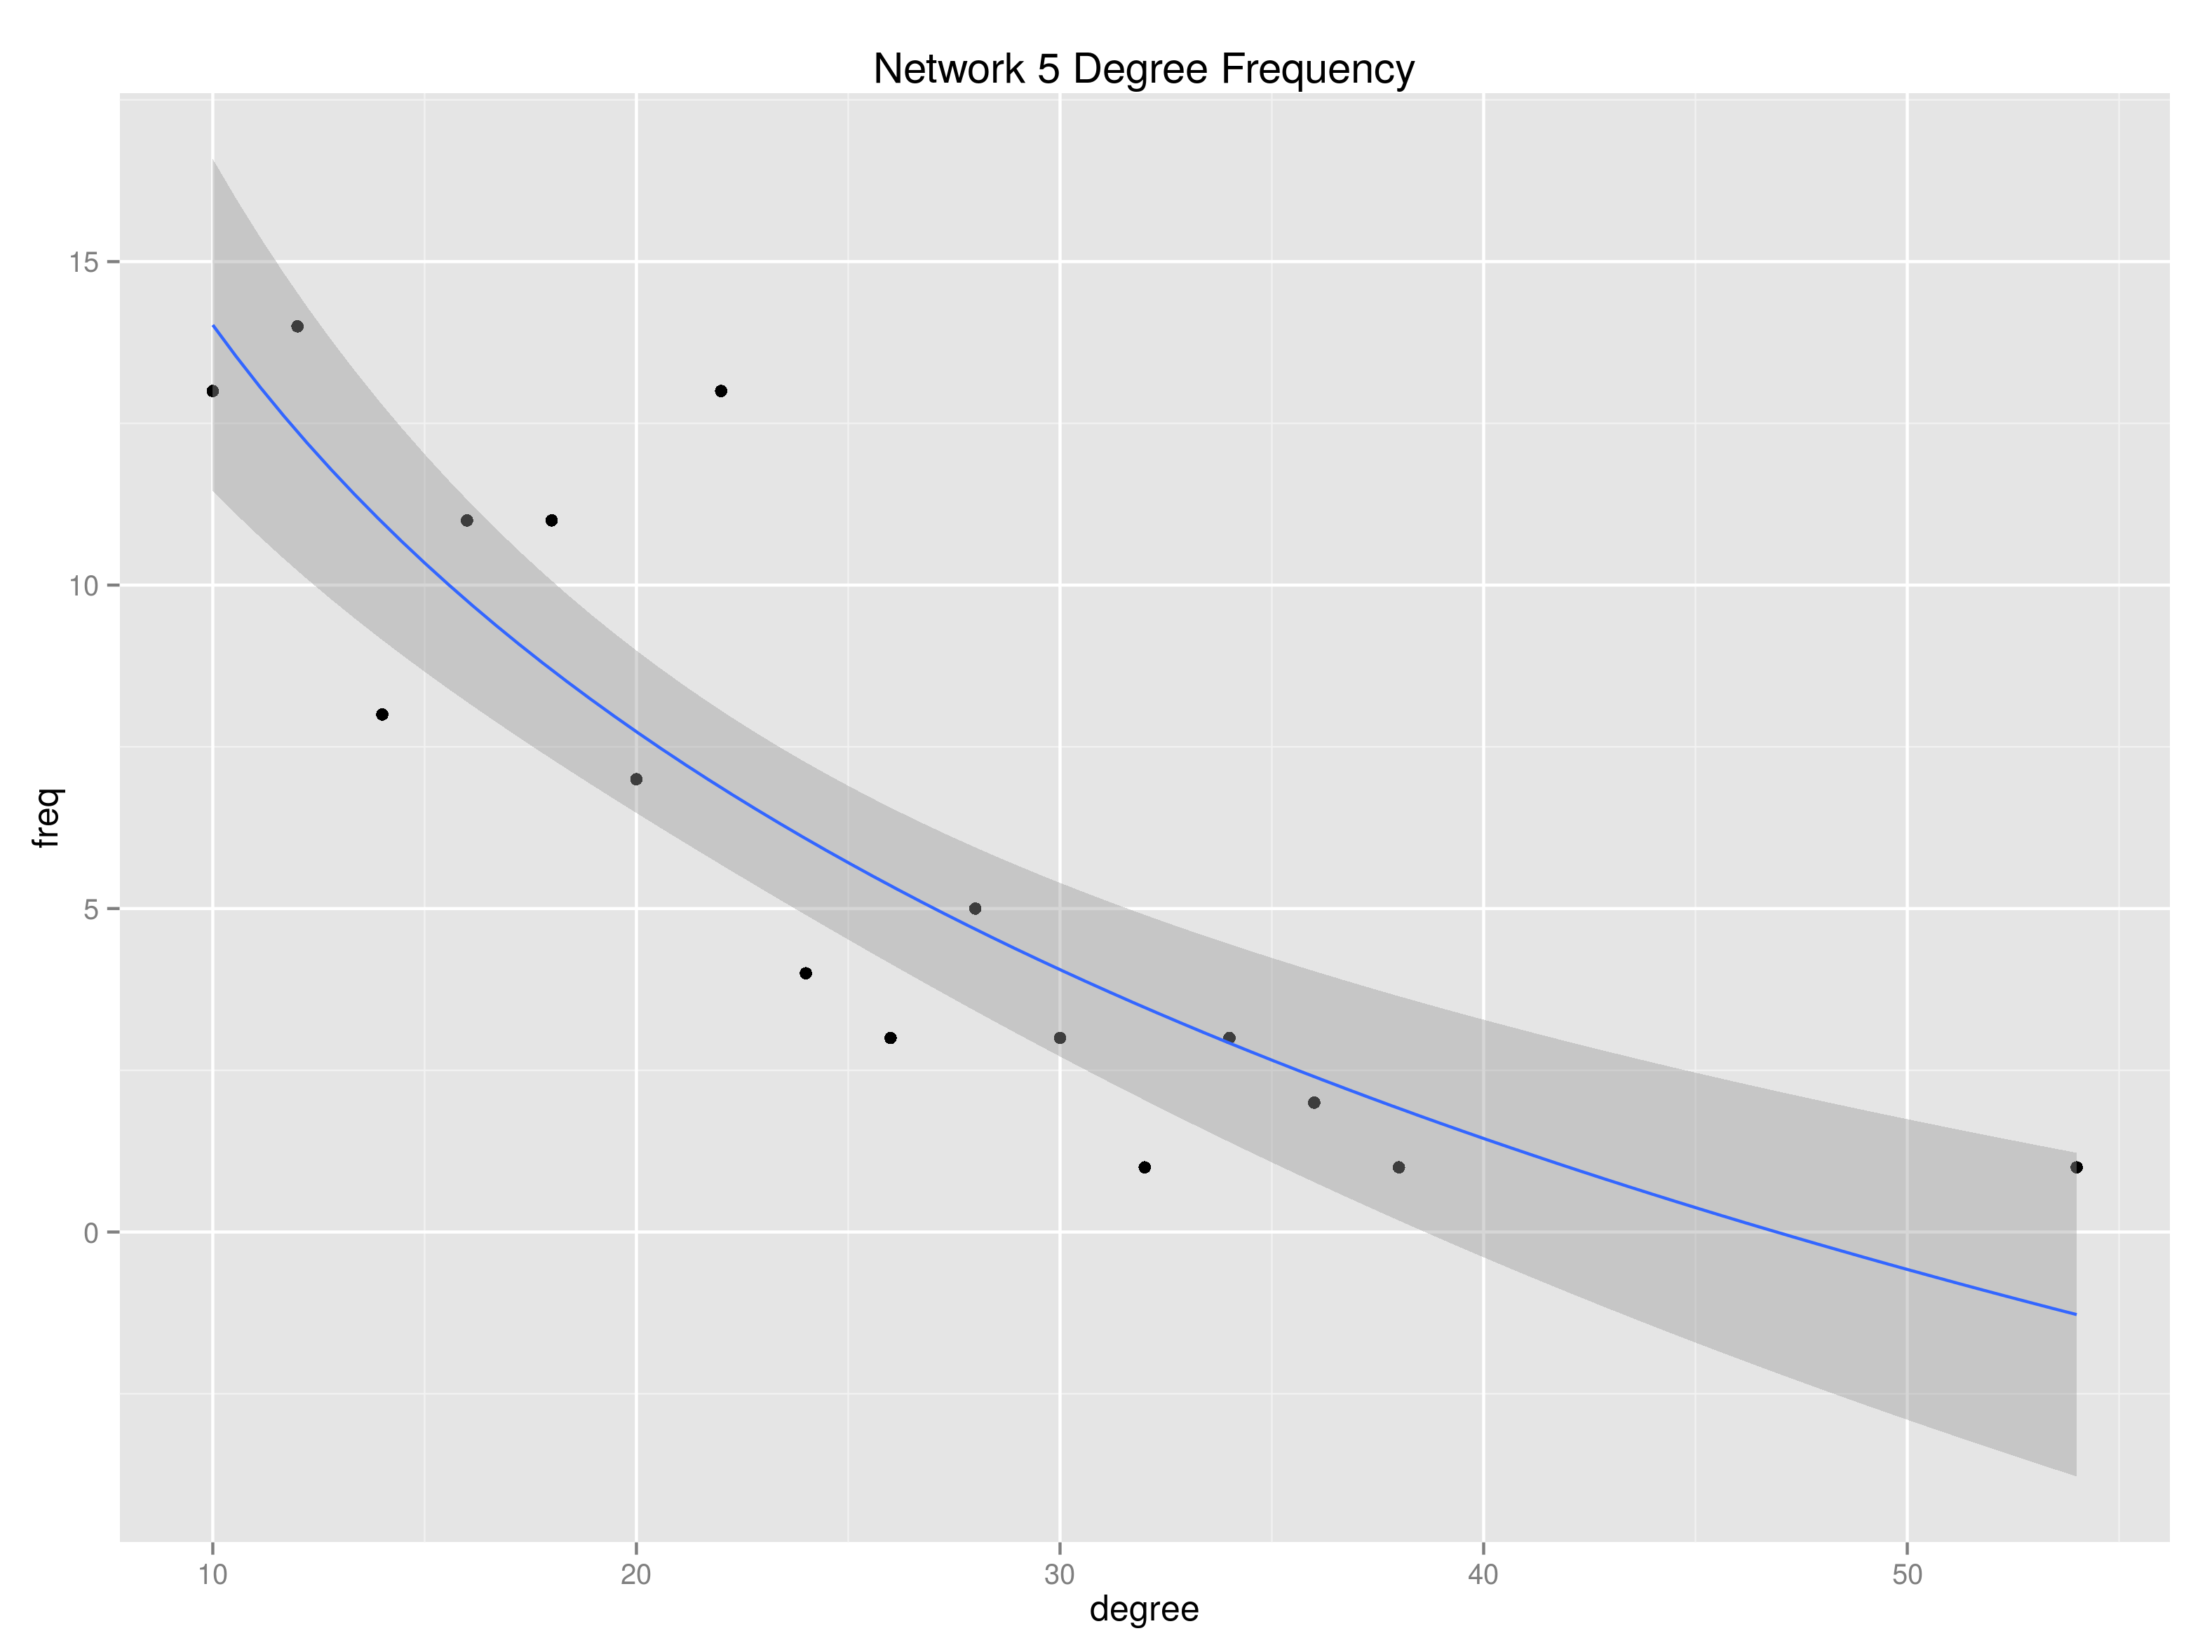

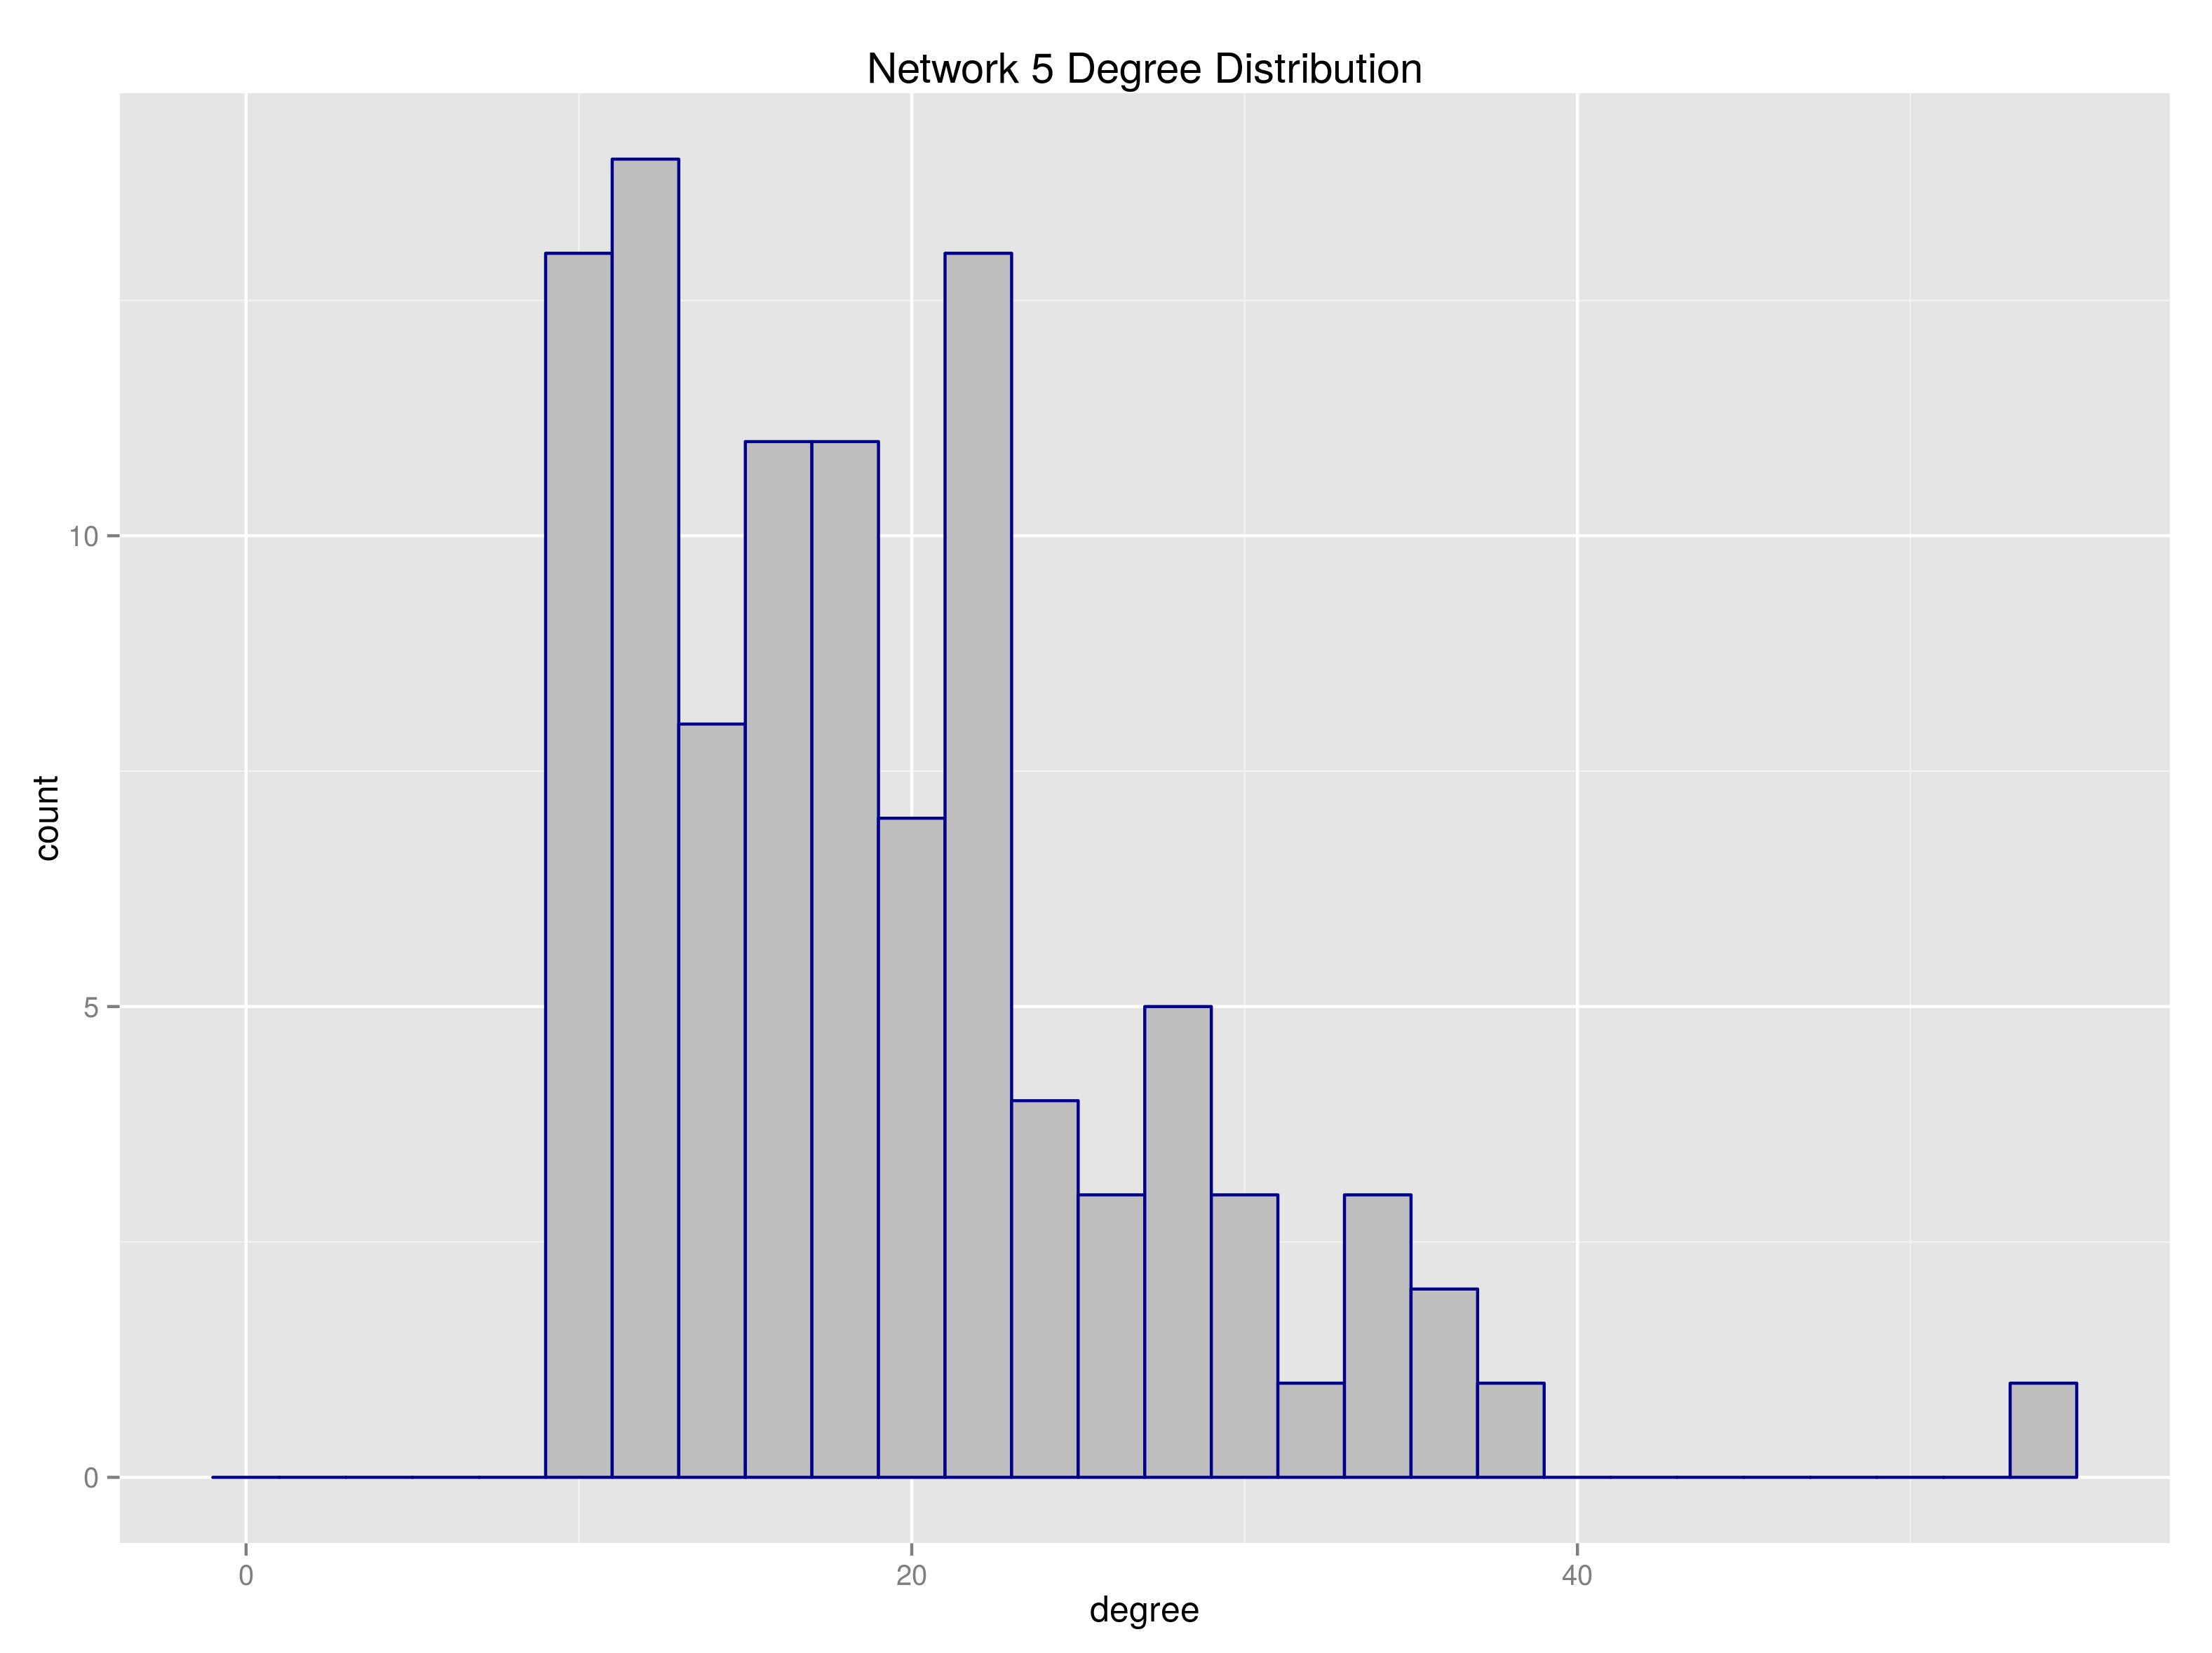

|  |  |
| --- | --- |
| Metric | Sample Network |
| "smallworldness" metric | 1.41070182 |
| global transitivity | 0.17755857 |
| mean transitivity from 300 random sub-nets | 0.11282573 |
| lower quantile transitivity, 300 random sub-nets | 0.09678792 |
| upper quantile transitivity, 300 random sub-nets | 0.12978730 |
| average shortest path | 2.52565657 |
| average shortest path, 300 random sub-nets | 2.26399798 |
| low quantile shortest path, 300 random sub-nets | 2.24493232 |
| upper quantile shortest path, 300 random nets | 2.28454646 |

References

**Adler and Wilkerson 2012**

Aldrich, John, 1995, *Why Parties?* University of Chicago Press

**Baumgartner and Jones 1993**

Bratton, Kathleen and Rouse, Stella, 2011, “Networks in the Legislative Arena: How Group Dynamics Affect Co-Sponsorship,” *Legislative Studies Quarterly*, Vol. 36, No. 3

Cain, Bruce, Ferejohn, John, and Fiorina, Morris, 1987, *The Personal Vote*

Cox, Gary W. and McCubbins, Mathew, 1993, *Legislative Leviathan: Party Government in the House*, University of California Press

Cox, Gary and McCubbins, Matthew, 2005, *Setting the Agenda*, Cambridge University Press

Denzau, Arthur, Riker, William and Shepsle, Kenneth, 1985, “Farquharson and Fenno: Sophisticated Voting and Home Style,” *The American Political Science Review*, Vol. 79, No. 4

Ferejohn, John, 1986, “Logrolling in an Institutional Context: A Case Study of Food Stamp Legislation,” in Congress and Policy Change, Gerald C. Wright, Jr., Leroy N. Rieselbach, and Lawrence C. Dodd, eds. New York: Agathon Press, Inc.

Fowler, James, 2006, “Connecting the Congress: A Study of Co-Sponsorship Networks,” Political Analysis,Vol. 14, No. 4

Gilligan, Thomas and Krehbiel, Keith, 1989, “Asymmetric Information and Legislative Rules with a Heterogeneous Committee,” *American Journal of Political Science*, Vol. 33, No. 2

Gilligan, Thomas and Krehbiel, Keith, 1990, “Organization of Informative Committees by a Rational Legislature,” *American Journal of Political Science*, Vol. 34, No. 2

Grannovetter 1978

Hall, Richard and Wayman, Frank, 1990, “Buying Time: Moneyed Interests and the Mobilization of Bias in Congressional Committees,” *The American Political Science Review*, Vol. 84, No. 3

Heclo, Hugh, 1978, “Issue Networks and the Executive Establishment: Government Growth in an Age of Improvement,” in *The New American Political System,* Anthony King (ed), American Enterprise Institute

Hojnacki, Marie and Kimball, David, 1998, “Organized Interests and the Decision of Who to Lobby in Congress,” *The American Political Science Review*, Vol. 92, No. 4

Jacobson, Gary, 1989, “Strategic Politicians and the Dynamics of U.S. House Elections, 1946-1986,” *American Political Science Review*, Vol. 83, No. 3

Jacobson, Gary, 1990, “The Effects of Campaign Spending in House Elections: New Evidence for Old Arguments,” *American Journal of Political Science*, Vol. 34, No. 2

Jacobson, Gary, 2012, *The Politics of Congressional Elections,* Longman Press

Jenkins, Jeffery, and Munger, Michael, 2003, “Investigating the Incidence of Killer Amendments in Congress,” *Journal of Politics*, Vol. 65, No. 2

Kingdon, John, 1989, *Congressmen’s Voting Decisions*, University of Michigan Press

**Kingdon, John, 1995,**

Krehbiel, Keith, 1991, *Information and Legislative Organization*, University of Michigan Press

Krehbiel, Keith, 1998, *Pivotal Politics: A Theory of U.S. Lawmaking*, Chicago University Press

Mann, Thomas, 1978, *Unsafe at Any Margin: Interpreting Congressional Elections*

Mayhew, David, 1974, *Congress: The Electoral Connection*, Yale University Press

Nourse, Victoria and Schacter, Jane, 2002, “The Politics of Legislative Drafting – A Congressional Case Study,” *New York University Law Review*, Vol. 77

Polsby, Nelson, 1968, “The Institutionalization of the US House of Representatives,” *American Political Science Review,* Vol. 62, No. 1

Poole, Keith and Rosenthal, Howard, 1997, *Congress: A Political-Economic History of Roll Call Voting,* Oxford University Press

Porter, Mason, Peter J. Mucha, M. E. J. Newman, Casey M. Warmbrand, 2005, “A network analysis of committees in the U.S. House of Representatives,” *Proceedings of the National Academy of Sciences of the United States,* Vol. 120, No. 20

Rhode, David, 1991, *Parties and Leaders in the Post-Reform House*, Chicago University Press

Shepsle, Kenneth and Weingast, Barry, 1987, “The Institutional Foundations of Committee Power,” The *American Political Science Review*, Vol. 81, No. 1

Talbert, Jeff and Potoskia, Matthew 2002, “Setting the Legislative Agenda: The Dimensional Structure of Bill Cosponsoring and Floor Voting,” *The Journal of Politics*, Vol. 64

Tam-Cho, Wendy and Fowler, James, 2010, “Legislative Success in a Small World: Social Network Analysis and the Dynamics of Congressional Legislation,” *The Journal of Politics*, Vol. 72, No. 1

Tullock, Gordon, 1967, "The Welfare Costs of Tariffs, Monopolies, and Theft," *Western Economic Journal*, Vol. 5, No. 3

Victor, Jennifer and Range, Nils, 2007, “The Social Utility of Informal Institutions: Caucuses as Networks in the 110th U.S. House of Representatives,” American Politics Research, Vol. 37, No. 5

Zhang, Yan, A.J. Friend, Amanda L. Traud, Mason A. Porter, James H. Fowler, Peter J. Mucha, 2008, “Community structure in Congressional co-sponsorship networks,” *Physica A: Statistical Mechanics and its Applications*, Vol. 387, No. 7

Humphries, M. D., & Gurney, K. (2008). Network "small-world-ness": a quantitative method for determining canonical network equivalence. PLoS One, 3(4), e0002051.

Newman, M. E. J. (2003). The structure and function of complex networks*. SIAM Review, 45(3), 167–256.

Csardi G, Nepusz T: The igraph software package for complex network research, InterJournal, Complex Systems 1695. 2006. <http://igraph.org>

Butts, Carter T., Mark S. Handcock, and David R. Hunter. (2014). network: Classes for Relational Data. R package version 1.9.0. Irvine, CA. <http://statnet.org/>.

Butts, Carter T. (2008). ``network: a Package for Managing Relational Data in R.'' Journal of Statistical Software, 24(2).

Handcock M, Hunter D, Butts C, Goodreau S, Krivitsky P and Morris M (2014). _ergm: Fit, Simulate and Diagnose Exponential-Family Models for  
Networks_. The Statnet Project (<http://www.statnet.org>). R package version 3.1.2, <http://CRAN.R-project.org/package=ergm>.  
  
Hunter DR, Handcock MS, Butts CT, Goodreau SM, Morris and Martina (2008). “ergm: A Package to Fit, Simulate and Diagnose Exponential-Family  
Models for Networks.” _Journal of Statistical Software_, *24*(3), pp. 1-29.

Epskamp, Sacha and Angelique O. J. Cramer, Lourens J. Waldorp, Verena D. Schmittmann, Denny Borsboom (2012). qgraph: Network Visualizations  
 of Relationships in Psychometric Data. Journal of Statistical Software, 48(4), 1-18. URL <http://www.jstatsoft.org/v48/i04/>.

Wickham, Hadley (2007). Reshaping Data with the reshape Package. Journal of Statistical Software, 21(12), 1-20. URL <http://www.jstatsoft.org/v21/i12/>.

Wickham, H. ggplot2: elegant graphics for data analysis. Springer New York, 2009.

Wickham, Hadley (2011). The Split-Apply-Combine Strategy for Data Analysis. Journal of Statistical Software, 40(1), 1-29. URL   
 <http://www.jstatsoft.org/v40/i01/>.

Sarkar, Deepayan (2008) Lattice: Multivariate Data Visualization with R. Springer, New York. ISBN 978-0-387-75968-5